

***APTECH LEARNING***

**Alphine ascents**

**GROUP MEMBERS**

**Rizwan**

**AbeerSiddiqui**

**Samyan Sheikh**

**Waqas ali**

**Muhammad asif**

**FACULTY**

**Miss ansa**

**PROJECT SUBMITTED**

**TO**

**APTECH LEARNING**

**ACKNOLEDGMENT**

**We are thankful to Almighty, ALLAH that by His grace we have been successful. We also thanks to “Sir Jabir”**

**This is our Second Year Semester E-project. We have tried our best & struggled for a better outlook to come. This project has been developed in Dream Weaver. We choose to make Website for Covid-19 as a project. We find easy to do coding in website.**

**We earnestly hope that this project will provide all the necessarily information required for the user to fulfill their inspiration. However suggestions for improvement of the project will be thankful received & acknowledge**

**PROJECT CERTIFICATION**

***This is to certify that,***

***xyz (Enrolment #) has successfully designed and developed:***

**Alphine Ascents**

***Submitted by***

***Aptech computer Education***

***Date of issue:***

**22-06-2024**

***Date of submission:***

**11-07-2024**

**INTRODUCTION**

***The thirst for learning, upgrading technical skills and applying the concepts in real life environment at a fast pace is what the industry demands from IT professionals today. However busy work schedules, far-flung locations, unavailability of convenient time-slots pose as major barriers when it comes to applying the concepts into realism. And hence the need to look out for alternative means of implementation in the form of laddered approach.***

***The above truly pose as constraints especially for our students too! With their busy schedules, it is indeed difficult for our students to keep up with the genuine and constant need for integrated application which can be seen live especially so in the field of IT education where technology can change on the spur of a moment. Well, technology does come to our rescue at such times!!***

***Keeping the above in mind and in tune with our constant endeavour to use Technology in our training model, we at Aptech have thought of revolutionizing the way our students learn and implement the concepts using tools themselves by providing a live and synchronous eProject learning environment!***

**HARDWARE&SOFTWARE/REQUIRMENT**

**Hardware:**

* **A minimum computer system that will help you access all the tools in the courses is a Pentium 2.45 or better**
* **256Megabytes of RAM or better**

**Software:**

* **Notepad/HTML editor**
* **Dreamweaver**
* **IE 5.0/ Netscape 6.0**

**PROJECT TIME DURATION**

1. ***Analysis-18 Hrs.***
2. ***Design – 22 Hrs.***
3. ***Development –20Hrs***
4. ***Testing – 12 Hours***
5. ***Documentation -11 hours***

***EPROJECT* Synopsis**

eProject is a step-by-step learning environment that closely simulates the classroom and Lab based learning environment into actual implementation. It is a project implementation at your fingertips!! An electronic, live juncture on the machine that allows you to

* Practice step by step i.e. laddered approach.
* Build a larger more robust application.
* Usage of certain utilities in applications designed by user.
* Single program to unified code leading to a complete application.
* Learn implementation of concepts in a phased manner.
* Enhance skills and add value.
* Work on real life projects.
* Give a real life scenario and help to create applications more complicated and useful.
* Mentoring through email support.

The students at the centre are expected to complete this eProject and send complete project along with the documentation to eProjects Team

Looking forward to a positive response from your end!!

**Snap shot:**

**Home Page**





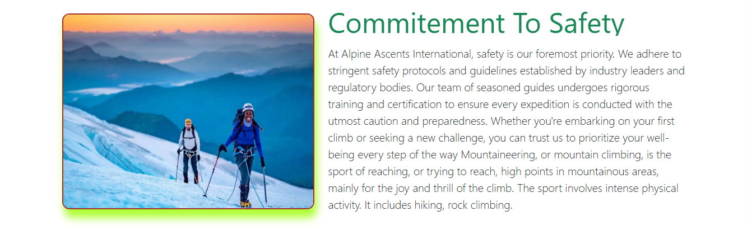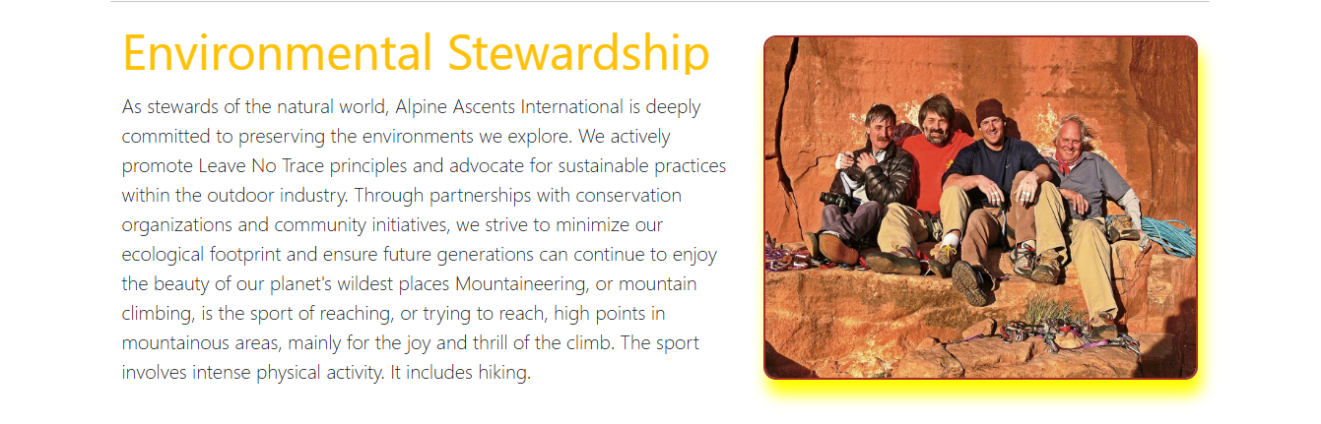

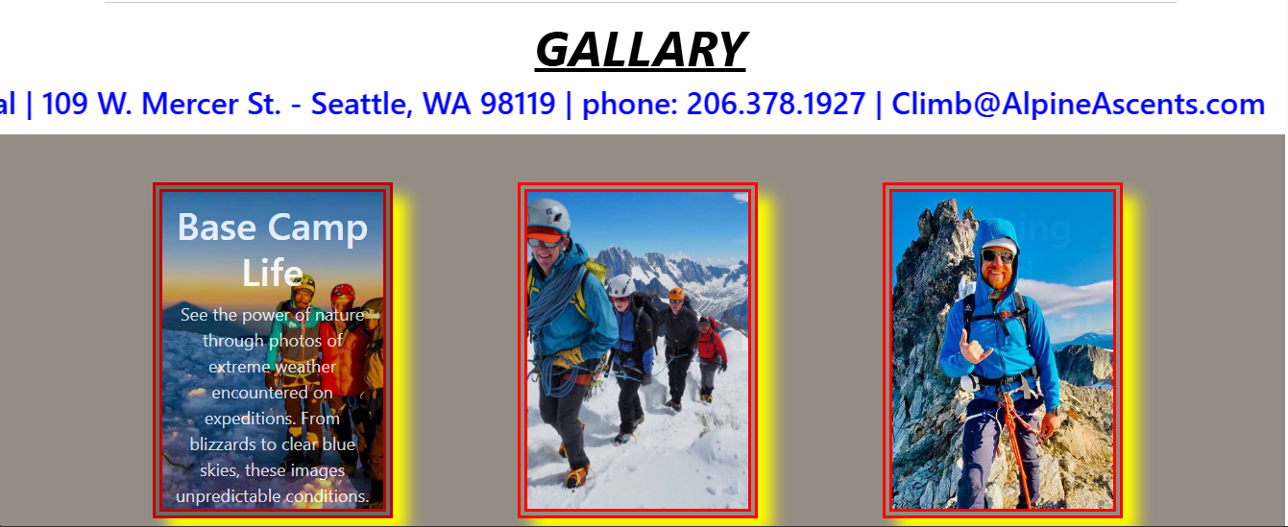



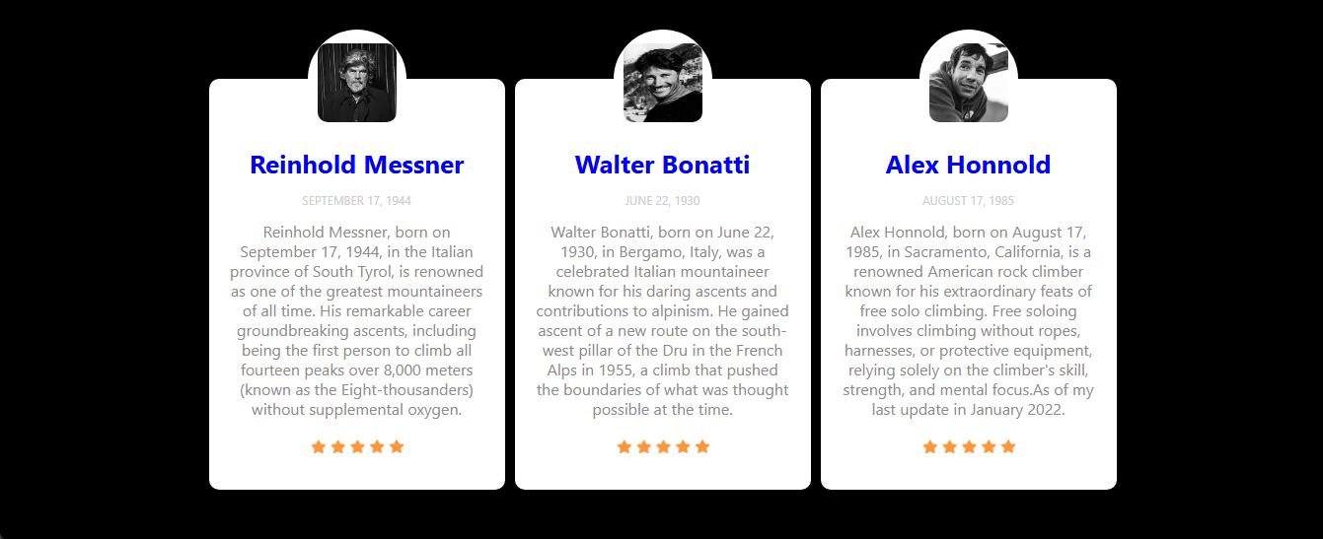

**types**



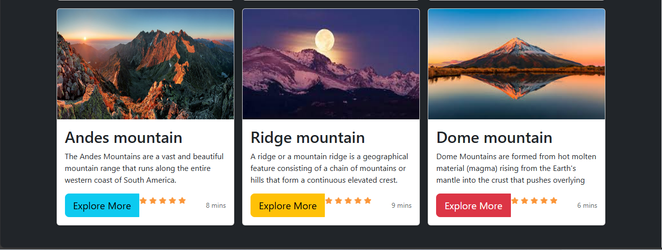

footer

